**Moment of Inertia**

Nov 2010 No 5

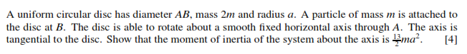

June 2014 P21 No 5

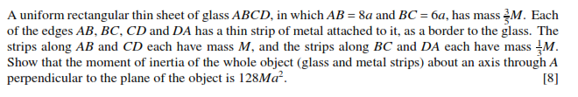

Nov 2012 P21 No 1

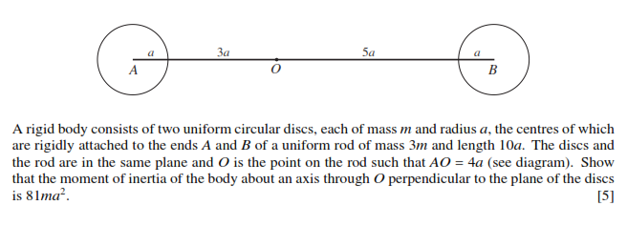

June 2011 P21 No11

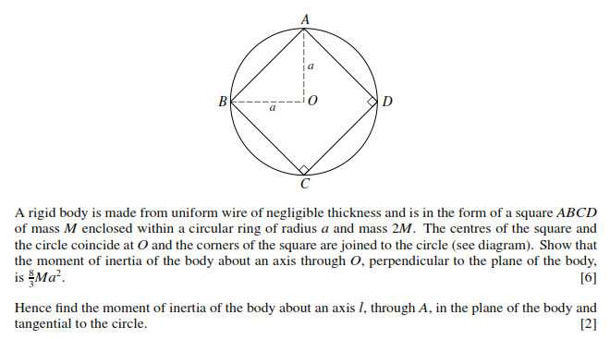

June 2015 P21 No 11

